
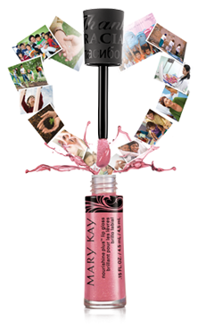
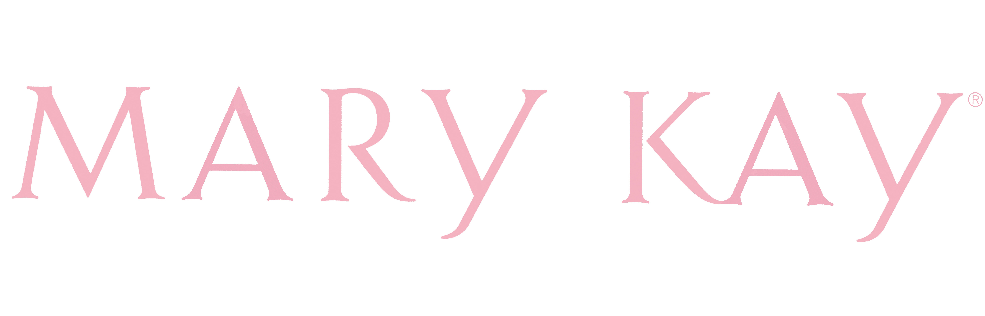
It’s as easy as THAT!
Host a Girls Night & Get $200.00 FREE!!!

Beauty Consultant:
Phone:
Email:
Website:

Earn $200.00 of FREE Mary Kay products in 5 EASY steps!!!
- Get $200.00+ in outside sales (friends, family, co-workers, etc. who
can’t make it. It’s super easy!)
- Hold Girls Night on the set day & time
- Provide your Beauty Consultant with your guest list 48 hours prior
- Have 5 guests over the age of 18 years old
- For every class booked, you get a 50% OFF item

It’s as easy as THAT!
Host a Girls Night & Get $200.00 FREE!!!

Beauty Consultant:
Phone:
Email:
Website:

Earn $200.00 of FREE Mary Kay products in 5 EASY steps!!!
- Get $200.00+ in outside sales (friends, family, co-workers, etc. who
can’t make it. It’s super easy!)
- Hold Girls Night on the set day & time
- Provide your Beauty Consultant with your guest list 48 hours prior
- Have 5 guests over the age of 18 years old
- For every class booked, you get a 50% OFF item

